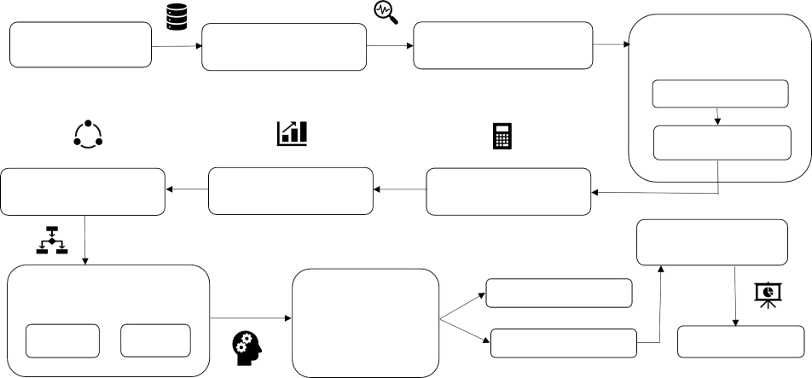Data Flow Diagram:

Data Flow Diagram & User Stories

|  |  |
| --- | --- |
| Date | 12Novemberer2022 |
| Team ID | PNT2022TMID53671 |
| Project Name | Efficient Water Quality Analysis and Prediction Using Machine Learning |

**DatasetCollection**

**DatasetUnderstanding**

**HandlingMissingValues**

**DataPre-processing**

Datanormalization

Min-maxnormalization

**ApplyingCorrelation**

**DataVisualization**

**WQICalculation**

**Resultingmodel**

**SplittingDataset**

**ApplyingMachine Learning**

**Algorithms**

**featureimprovement**

**Training**

**Testing**

**Modelling**

**comparingresult**

**User Stories**

|  |  |  |  |  |  |  |
| --- | --- | --- | --- | --- | --- | --- |
| **User Type** | **Functional Requirement**  **(Epic)** | **User**  **Story Number** | **User Story/Task** | **Acceptance criteria** | **Priority** | **Release** |
| People (web user) |  | USN-1 | As a user, I can understand the detailed description of water quality on the homepage | I can access the web page | High | Sprint-1 |
|  | Input form | USN-2 | As a user, I can enter the details required to | I can give inputs in the | High | Sprint-2 |
| analyze the water quality with use of form | form and it is processed |
| provided in the web page. | and visualize the water |
|  | quality. |
|  |  | USN-3 | As a user, I can contact the customer care | I can contact people | Medium | Sprint-3 |
|  | (people at the waterer source organization) to know the details of water. | through whatsapp, Instagram, twitter, mail and can also make a call. |  |  |
|  |  |  |  |  |
|  |  |  |  |  |